Performing EDA on Dataset

Category : Machine Learning

Project Description:

In this project, you need to analyze the dataset and use different methods of NumPy, Pandas, and different exploratory methods to analyze and find the insights in the dataset.

Project explaination:

In this project, I performed the exploratory data analysis on the bike data set. (The data set which you have given in project details is not opened for me.) Hence, I downloaded a dataset from the kaggle website and finished this project.

At first I loaded dataset and did some numpy operations as shown below.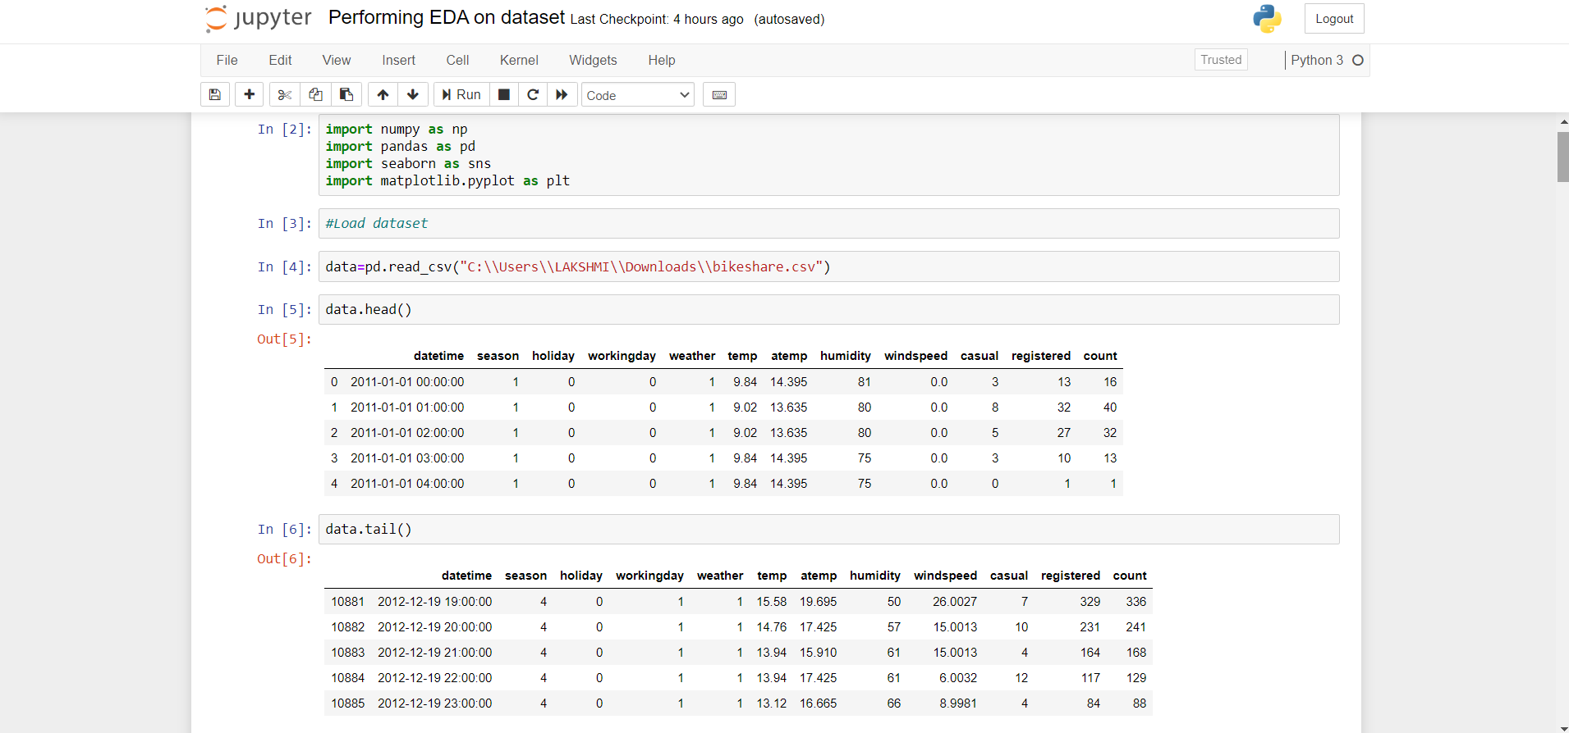

And some other operations on dataset like tail, head ,nunique, columns, unique, value_counts, isnull() etc,.

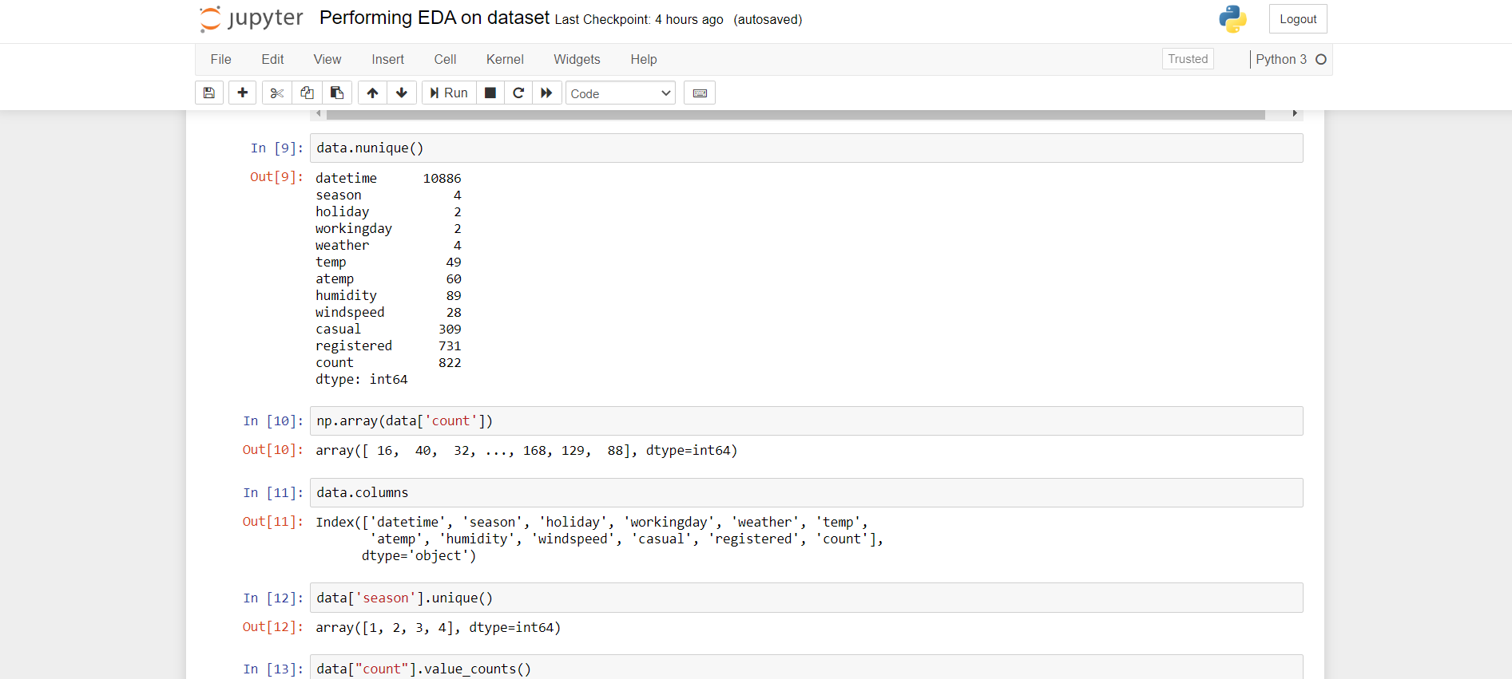

And I performed the plotting like box plot,bar plot, histogram, pie chart, heat map, and etc.,

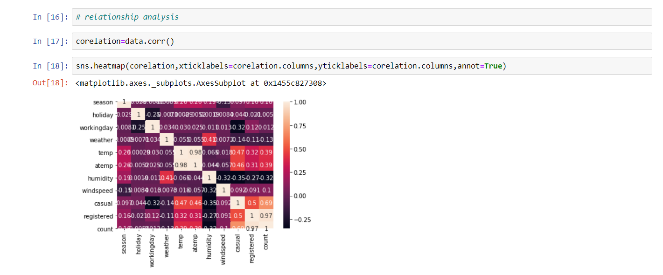

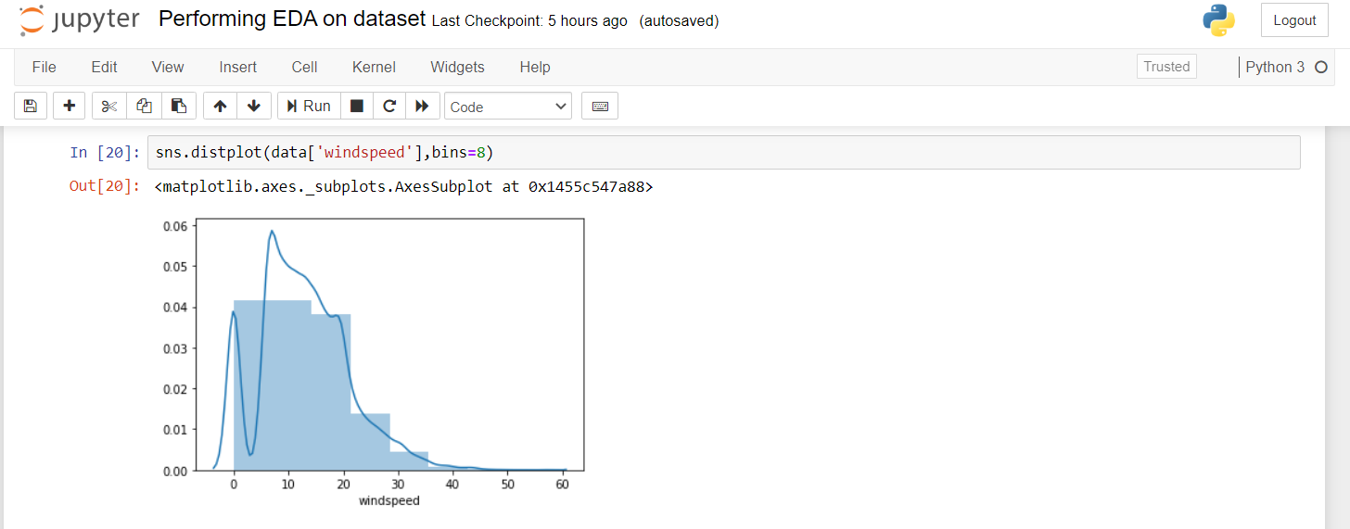

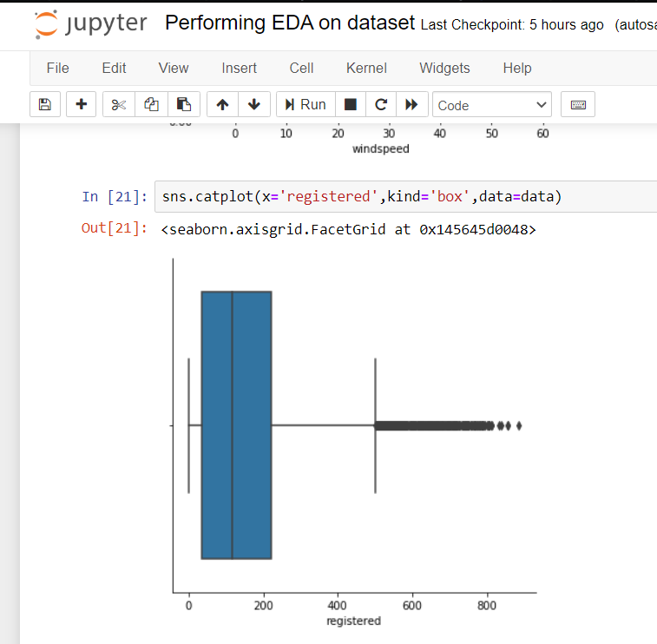

# 

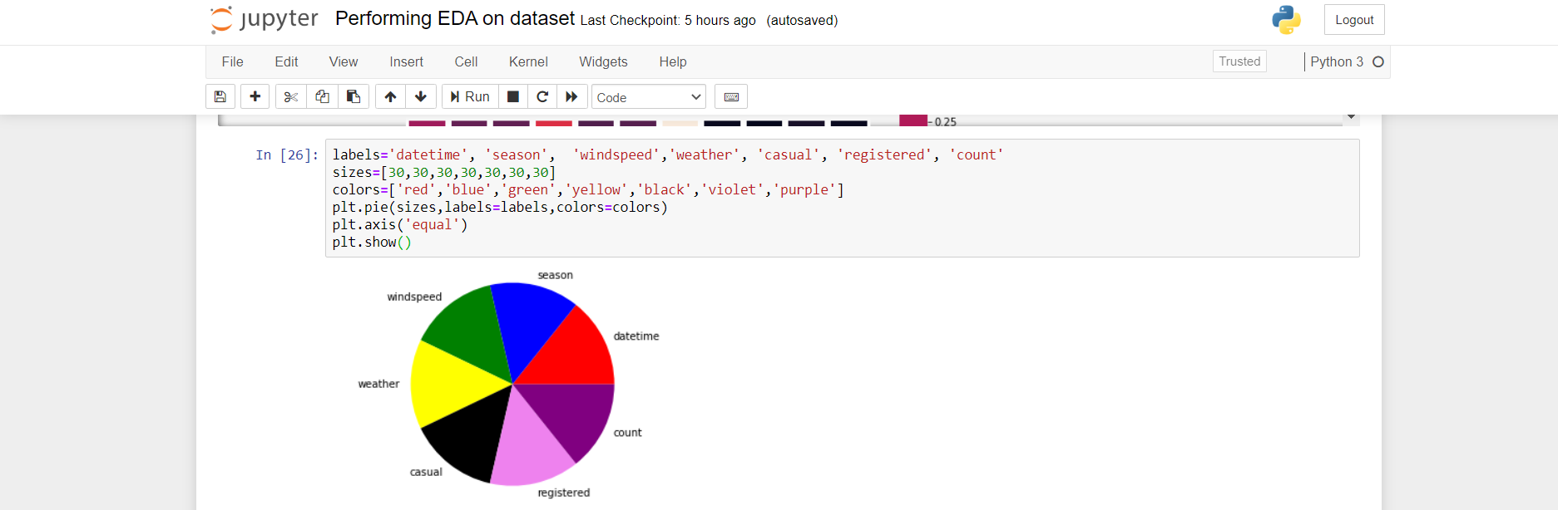

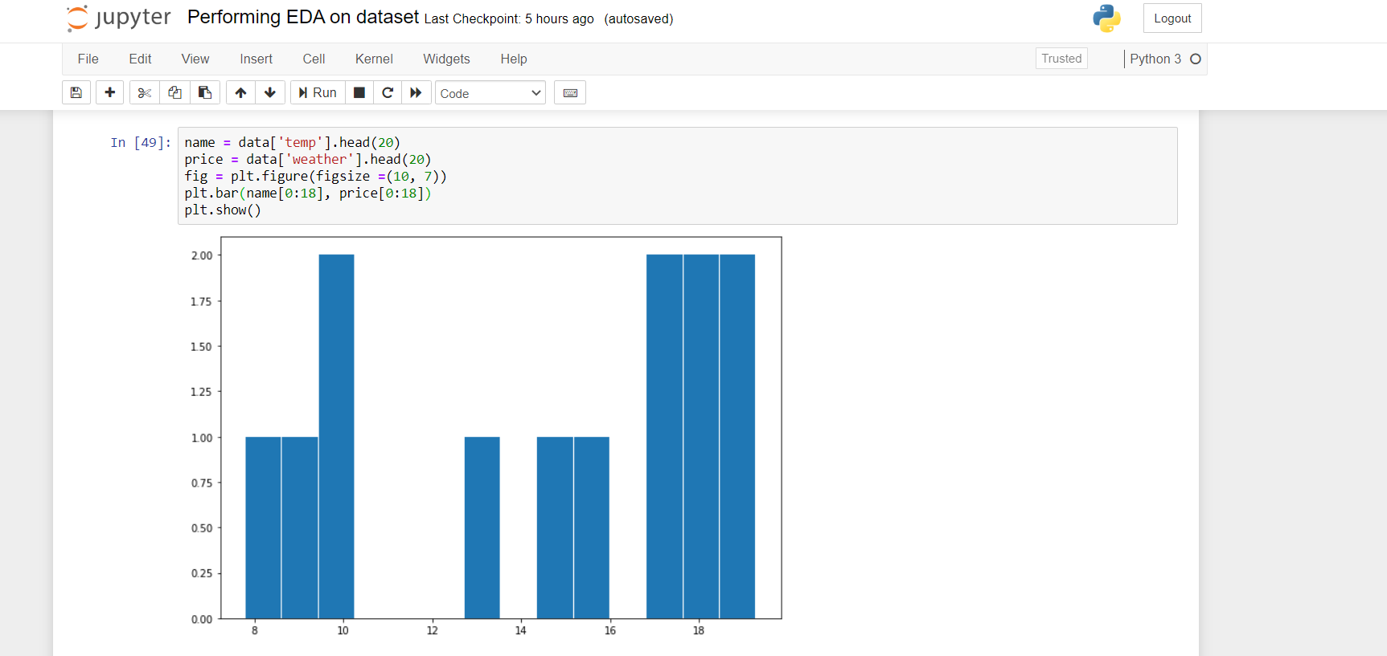

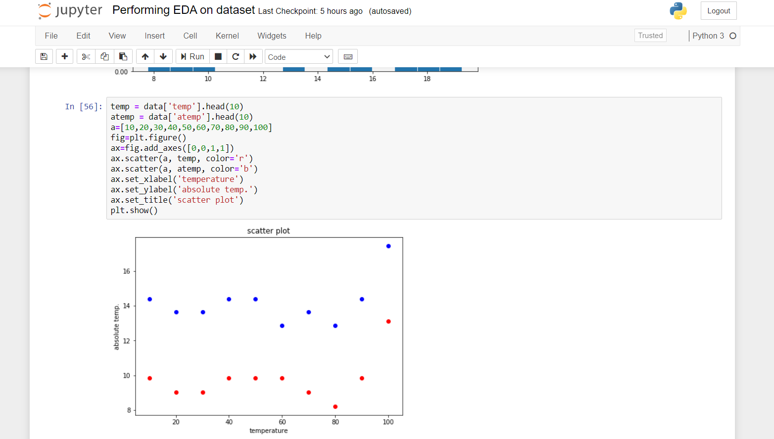

Hence, this is my final report in which I done the operations on the dataset.